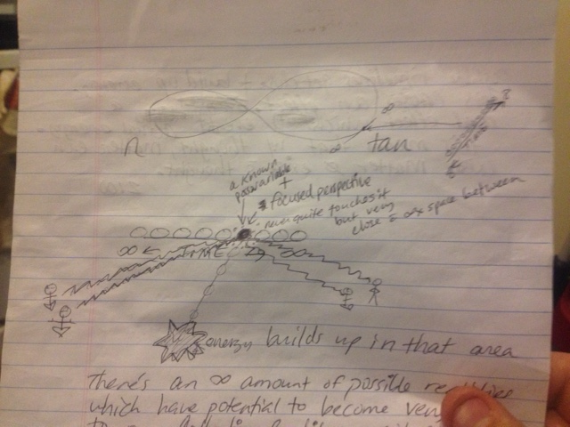

There’s an infinite amount of possible realities which have potential to become very close to our collective reality – not quite the same because A does not equal B.

* Seems like this would happen if our timelines could cross or come very close so that a new collective perspective is created (maybe a disaster happens to cause / or that leads to this ∆ of collective perspective)

Our possible y variables continue to have a ghost timeline and create infinite ghost timelines. They become “real” due to the possible ghost energy when these possible timelines get close and build up energy.

This causes an effect, a real effect which creates actual energy. This means that with thought, matter can exist. Matter doesn’t exist without thought.

2100